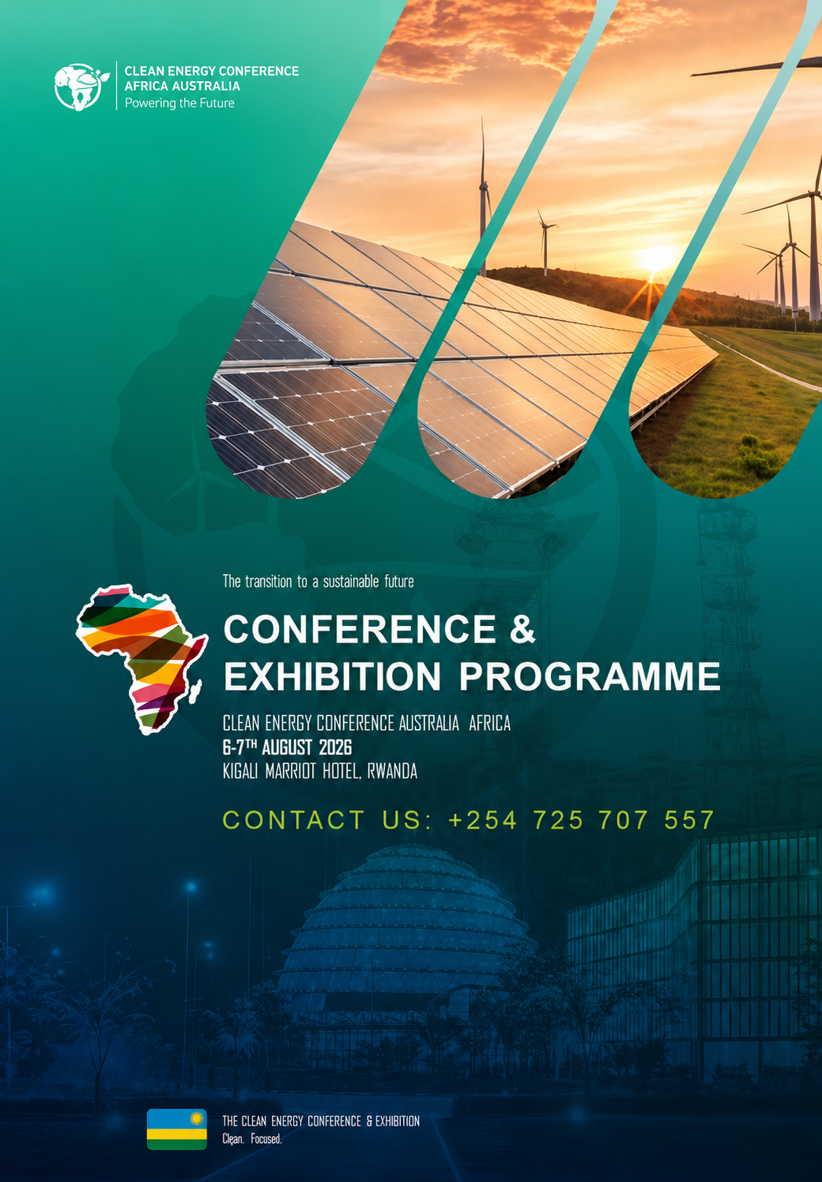

CLEAN ENERGY CONFERENCE AUSTRALIA AFRICA 2026
AUSTRALIA EDITION- 31ST AUGUST 2026, AT THE NOVOTEL, PERTH AUSTRALIA
THE PROGRAMME

DAY ONE- 31 AUGUST 2026

8:00 – 8:45 a.m. | Registration and Welcome Refreshments.  National Anthem & Conference opening by MC-
8:45 – 9:00 a.m. | Opening Remarks  Stephen Kuria, Executive Chairman, Australia Kenya Chamber of Commerce.
9:00 – 10:00 a.m. | SESSION 1- Opening Address  Opening Keynote Address  Geopolitical of Energy- Developments, supply chain realignments, Power infrastructures and changing global energy landscape- the macroeconomic forces influencing African energy  H.E Minister of Energy Kenya  H.H. E Minister of Energy Tanzania  H.E. Minister of Energy Uganda  H.E. Minister of Energy South Africa  H.E. Minister of Energy Nigeria  Fireside Chat  Global trade and geopolitics have continued to evolve affecting investor and political perception of exploration. With the U.S. Administration focused on the promise of cheaper, reliable and secure energy and a sudden shift across much of the west from a rapid energy “transition” to more rational energy policies, will calls for increased supply support or challenge exploration in Africa? The panel aims to explore the impact of these shifts on exploration and capital investment in Africa, where E&P companies have expanded interest in frontier areas and the fundamental need for energy access remain paramount.
10.00-10.30 a.m. | Networking Break and Exhibition Visit
SESSION 2- The Australian Energy Crossroads: A Bridge or a Barrier?
Australia stands at a pivotal junction, balancing its role as a global energy powerhouse with the urgent necessity of a sustainable future. As we navigate the dual mandates of energy security and ambitious climate targets, the debate over the role of natural gas has never been more volatile or more vital.
Is natural gas the pragmatic foundation for Australia’s energy reliability, or are we clinging to an infrastructure that compromises our commitment to a cleaner future?
Today, we bring together leading policymakers, technical innovators, and financial experts to strip away the rhetoric. We are here to challenge the status quo and interrogate the trade-offs:
How do we reconcile the immediate demand for affordable, dispatchable energy with the imperative of rapid decarbonization?
Are our current financial and regulatory frameworks accelerating the transition, or are they inadvertently locking us into long-term climate risk?
Can natural gas truly act as a catalyst for cleaner energy adoption, or is it merely slowing the momentum toward renewables?
The floor is open for a rigorous, no-holds-barred debate. Let’s confront the complexities of Australia’s energy landscape and define what "optimal" really means for our national development.

11:30 -12:30 p.m. | SESSION 3- Unleashing Capital: Are We Removing Barriers or Building New Walls?  Global energy transition requires unprecedented levels of capital, yet the path for investors remains cluttered with red tape, shifting regulatory sands, and structural uncertainty. While G20 nations and emerging economies hold the keys to a cleaner future, the persistent friction in our investment frameworks is stalling progress when we need speed the most.  Are we genuinely committed to de-risking the energy transition, or are we trapped by the very bureaucratic hurdles and legal inconsistencies that keep capital on the sidelines?  Today, we bring together the architects of global finance and policy to move beyond the usual platitudes. We are here to confront the reality of why, despite the massive global appetite for sustainable projects, investment continues to be stifled.  Which regulatory roadblocks are truly obsolete, and why do they persist in the face of our climate goals?  Is it a lack of capital, or a lack of courage in reform that is preventing the surge of Foreign Direct Investment (FDI) into our most critical markets?  How do we harmonize legal frameworks across borders to move from disjointed, risk-averse initiatives to a truly global, efficient energy market?
12.30-13.20 p.m. | Lunch and Sponsor Showcase
13:30 -14:30 p.m. | SESSION 4- The Energy Crossroads: Innovation, Extraction, or Illusion?  We are at a critical juncture in the global energy transition. We’re banking on the earth’s heat, betting on carbon capture, and scrambling to find the trillions needed to fund it all. But as the clock ticks toward 2030, we have to move past the glossy brochures and get honest about the risks we’re taking.  This panel isn't just about sharing updates; it’s about testing our resolve. We’ll be dismantling the following tensions:  The Geothermal Gamble: We’re eyeing next-generation geothermal to provide constant, clean power. But are we ready to scale industrial-grade drilling and hybrid systems without repeating the environmental mistakes of the past?  The CCUS Conundrum: Carbon Capture, Utilization, and Storage is being hailed as the lifeline for oil, gas, and mining. Is this the pragmatic bridge to a net-zero future, or is it a convenient excuse to keep the carbon-heavy status quo on life support?  The Financing Chasm: The capital exists, but the "risk" doesn't disappear just because it’s labeled green. With renewable projects struggling to secure bankable models, are we creating genuine risk-sharing partnerships, or just shifting the burden onto the next generation?
14:30 - 15:30 p.m. | SESSION 5- Sovereignty, Velocity, and the Investment Crunch  Australia is at a defining juncture. We have the world-class natural resources to become a renewable energy superpower, yet we find ourselves caught in a "trilemma": racing to build a resilient, decarbonized grid while grappling with the vulnerabilities of a digital-first energy system and a stalling pipeline of large-scale investment.  Are we truly building a sovereign, future-proof energy system, or are we simply swapping one form of dependence for another?  As we shift from ageing coal to a decentralized, electrified future, the stakes have shifted from mere capacity to the very integrity of our infrastructure—digital, physical, and financial. Today’s panel cuts through the policy noise to address the hard questions:  Digital Sovereignty: In an era of AI-driven demand and global cyber threats, can Australia build energy systems that are truly secure and self-reliant, or are we structurally tethered to opaque global technology supply chains?  The Powerhouse Paradox: We have the wind and sun, but is our current grid architecture—and our progress in training the next-generation workforce—actually capable of handling the speed of this transition, or is our "powerhouse" ambition currently outpacing our engineering reality?  The Investment Gap: Billions in capital are waiting on the sidelines while developers face connection queues, planning bottlenecks, and grid congestion. Is the market currently optimized to attract the long-term capital we need, or are we failing to provide the certainty investors demand?  The panel is set, and the mandate is clear: let's move beyond the rhetoric of "clean energy" and interrogate the structural, digital, and financial systems that will determine if Australia leads or lags in the global energy race.
15:30 – 16:30 p.m. | SESSION 6- The Efficiency Dividend: Australia’s Untapped Economic Engine  For too long, energy efficiency has been viewed as a dry, technical box to tick—a matter of insulation ratings and appliance labels. It is time to flip the script: Efficiency is not just a technical challenge; it is Australia’s most significant, and most ignored, economic opportunity.  Are we genuinely empowering Australian households to become active, rewarded managers of our energy future, or are we simply asking them to bear the cost of an aging, inefficient system?  Today, we move beyond the jargon to demand accountability. We are bringing together the visionaries and the implementers to confront the gap between our potential and our performance:  The Demand-Side Reality: Are our current demand-side management programs actually delivering relief to household budgets, or are they failing to gain the public trust required for mass adoption?  The Community Scale-Up: Why do high-impact, community-based efficiency projects remain localized success stories while our national energy strategy struggles to scale these models effectively?  The Prosperity Gap: If energy saved is truly energy earned, why haven't we treated efficiency as a primary resource, equal in priority to generation?  The panel is set to challenge the status quo. We are here to debate the policies and practical initiatives that will move us from passive consumption to active, grid-stabilizing prosperity.
SESSION 7- The Data Center Dilemma: Balancing Infrastructure and Energy Sovereignty
The question of whether Australia can "remove" community-integrated data centers is complex, as it pits the necessity of digital infrastructure against the strain on our national energy grid. While removing them entirely is economically and technologically unfeasible—given their status as the backbone of our digital economy—the current debate is focused on relocating, regulating, and revolutionizing how they operate.
Can We Remove Them?
"Removing" data centers from communities is currently being framed by policy experts and community groups not as an abolition, but as a de-clustering strategy. The primary issue is the current concentration of hyperscale facilities in urban areas, which creates "localized grid exposure," straining substations and competing for water and power with local residents.
The Case for Decentralization: Shifting smaller or non-latency-critical workloads to regional areas—where land is abundant and renewable energy can be generated on-site—is increasingly viewed as a viable alternative to the "Sydney-centric" model.
The Constraints: High-speed fibre connectivity and the need for proximity to a skilled technical workforce mean that complete removal from urban hubs is impractical for many latency-sensitive AI applications.
How to Supply Power Needs
If the goal is to sustain these facilities without cannibalizing the energy required for homes and businesses, the focus is shifting toward "co-location" and "dedicated capacity":
Renewable Energy "Additionality": Policymakers and critics are pushing for data centers to move beyond simple offsets. True sustainability requires "additional" renewable generation—meaning data centers must fund and build new wind, solar, and battery storage projects that wouldn't have existed otherwise, rather than just buying existing green power.
Off-Grid and Microgrid Integration: For regional centers, there is growing potential for dedicated renewable microgrids. By pairing data centers directly with large-scale solar or wind farms, operators can bypass some grid congestion and operate more independently.
Demand Response and Flexibility: New technical standards are being introduced (such as those by the AEMC) to force data centers to be "grid-responsive." This means these facilities could potentially ramp down their power usage during peak grid stress periods, essentially acting as a giant "battery" that helps stabilize the grid rather than draining it.
Efficiency Standards: Mandating higher Power Usage Effectiveness (PUE) ratings ensures that every megawatt consumed is optimized for performance rather than lost to inefficient cooling or legacy server architecture.
The Bottom Line
Australia is currently transitioning from a "growth at any cost" model to one defined by national interest. The government’s recent "Expectations of data centres" framework signals that operators must now prove their contribution to the energy transition, water security, and grid resilience. The path forward is not to remove these vital digital hubs, but to mandate that they become net contributors to Australia's renewable energy capacity rather than just passive consumers.
16.30 p.m. | Evening Tea and Networking

